Registering for MyMathLab – BMCC Instructors
Spring and Fall 2015

Go to www.maymathlab.com.

Click on SIGN IN.

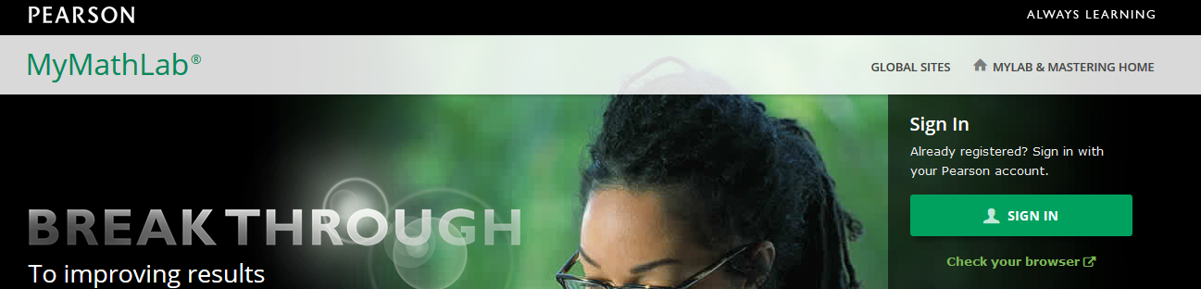

Your username is your BMCC email address: firstinitiallastname@bmcc.cuny.edu for example, jsmith@bmcc.cuny.edu.

Your password has been set by the math department. Contact Mark Jagai for this semester’s password.

Once you are logged in, please change your password by going to ACCOUNT on the top far right corner of the screen.
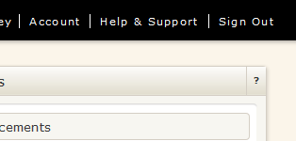

You will then be asked to enter your username and password again – use the old password you were given.

Next, click
You can change your email address here as well as your password. Do not change your username (turn the page over for more information).
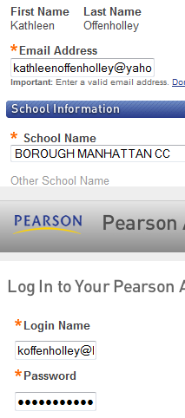

You can change this email address.

Do not change this, your user name.

Please change your password.

Once you have change your password, you can close this window and go back to the main entry page, at www.mymathlab.com.

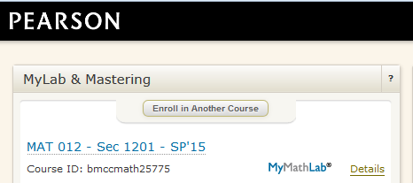

Your Course Id, which you will give to your students so that they can enroll, is under the number and section of the course.

Click the blue title of the course to get into your course and see the assignments.

