Registering for MyMathLab – BMCC Students

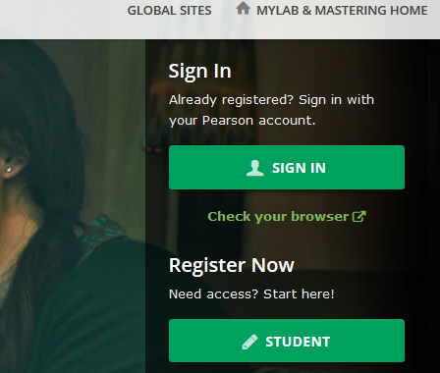
Go to www.maymathlab.com.

Under REGISTER NOW, click on
STUDENT.

Or, if you already have a Pearson Account from another class (any MyLab class, including if you took this class before), click SIGN IN.

On the next page, click OK! Register now.
You do not have to have a credit card now -- you can have free access for 14 days. But if you can, it’s better to pay today instead of waiting until the trial period is over.

Enter the Course ID given to you by your professor.

Click CREATE to create an account. Use the email address you prefer (it does not have to be BMCC email).

Once you have logged in, click on the letters at the bottom of the page to get temporary access without payment.
